**Network and Servers**

**Lpa-NSI-Checklist**

**DITS-NETSRV - Plan and design network server to meet business requirements (Prototype and install network server.)**

**ICT50715**

Diploma of Information Technology (Software Development)

Intermediate Programming

**Assessment**

**Task 1(b) and 2 By** DIEGO HENRIQUE GONCALVES

**Student No:** CTI2017271

**For CTI Info.**

**Tech. Date:** 09/04/2018

1. **ABSTRACT**

About the document, it is need to explain and view the way to get the best structure to configure a complet application.

**Summary**

**1.Abstract**2

**2.Introduction**4

**3.****Check-List**5

**4. Check-List setup** 5

Install CentOS5

Configure IPAddress7

Install MariaDB and MySql DataBase11

Install Apache15

Install PHP17

Install PHP-MySql21

Install PHPMyAdmin22

Configure LPA-stock-control users25

Administrator users25

Others users27

**5. Conclusions**28

**6. Recommendations**28

**7. References**29

1. **INTRODUCTION**

Configure and install part of the network plan to execute and up the structure to LPA enterprise, this part is destinatet to a PHP applications based on MySql database server.

1. **Check-List**

* Install CentOS
* Configure IPAdress
* Install MariaDB and MySql DataBase
* Install Apache
* Install PHP
* Install PHP-MySql
* Install PhpMyAdmin
* Configure LPA-stock-control users
* Administrator users
* Others users

1. **Check-List Setup**
   1. **Install CentOS**

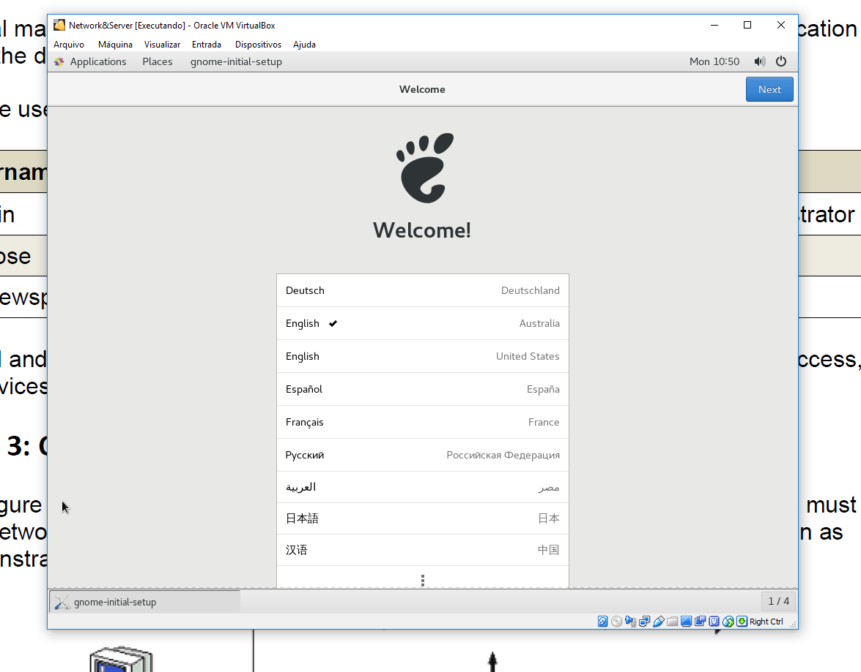

1 - After install .ISO on VirtualBox, configure language

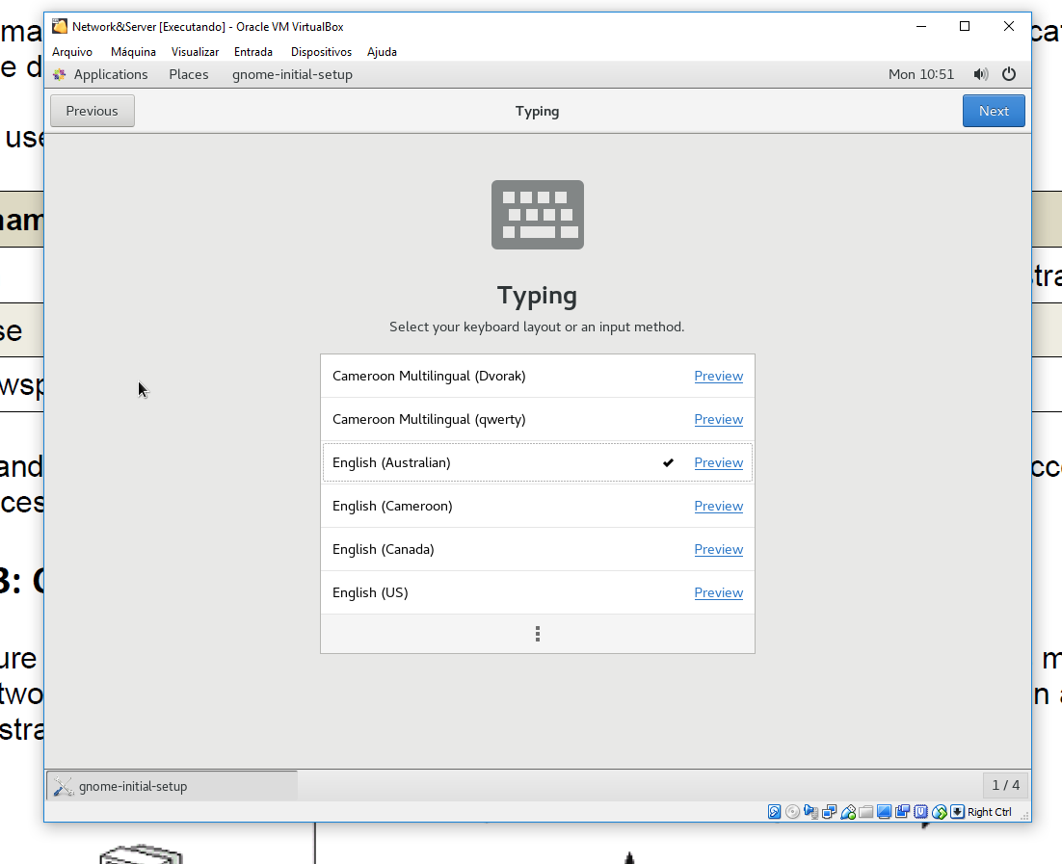

2 - For complete install configure KeyBoard

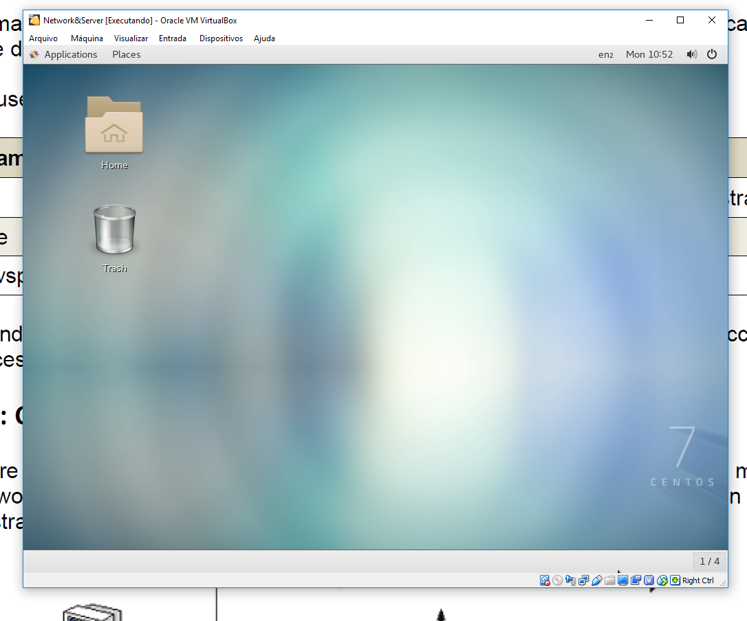

3 - Complete install CentOS 7

* 1. **Configure IPAdress**

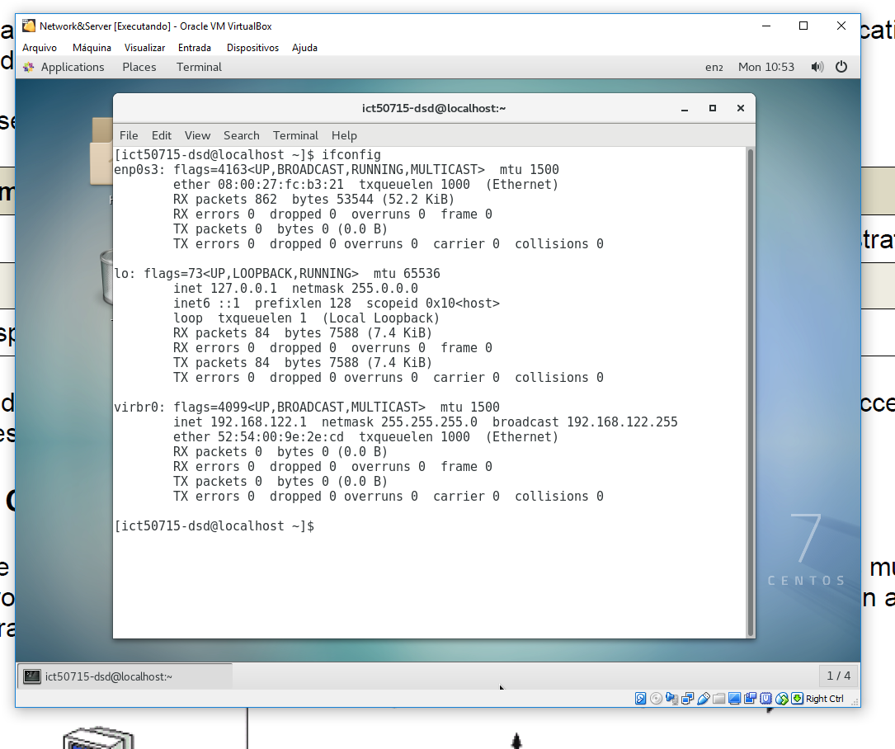

4 - Command to view network parameters

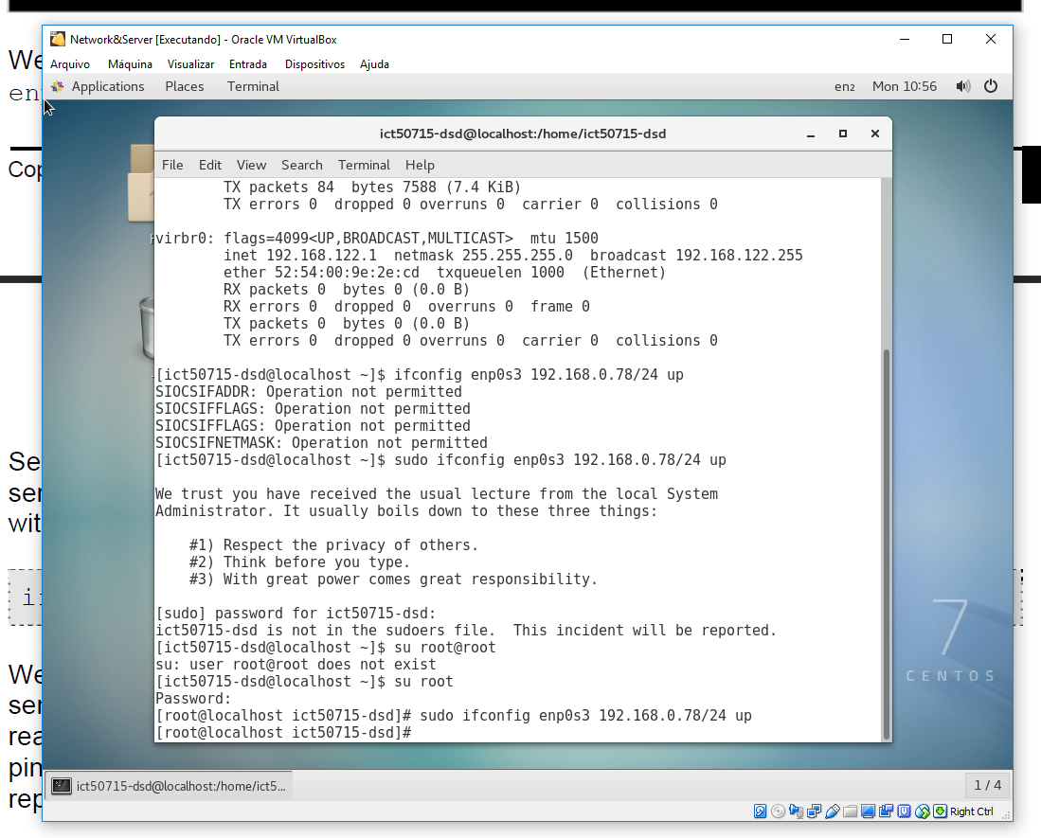

5 - Command to change IPAddress

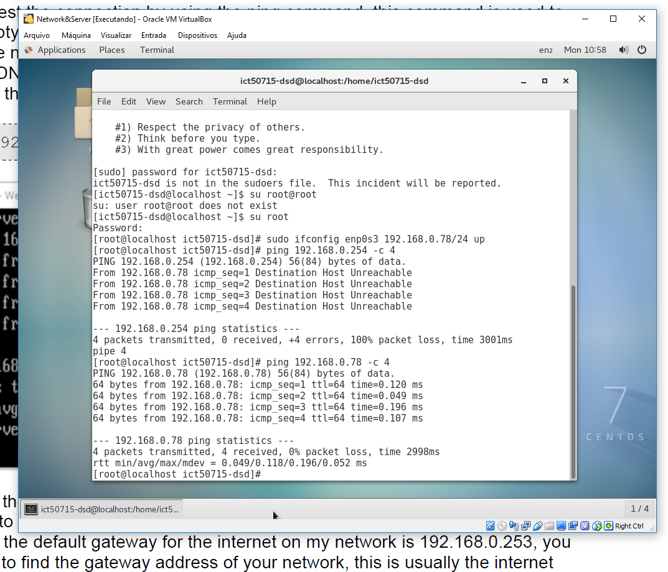

6 - Command to validate new IP

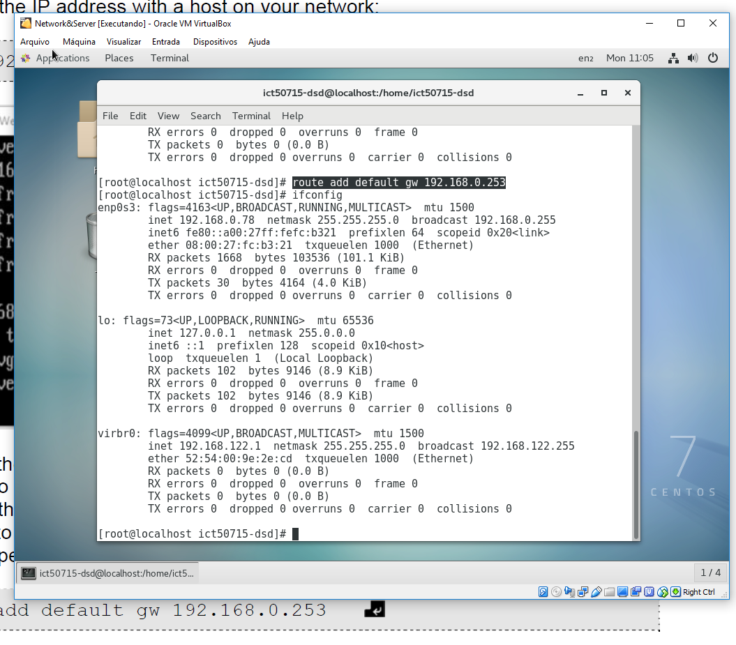

7 - Command to change DNS default

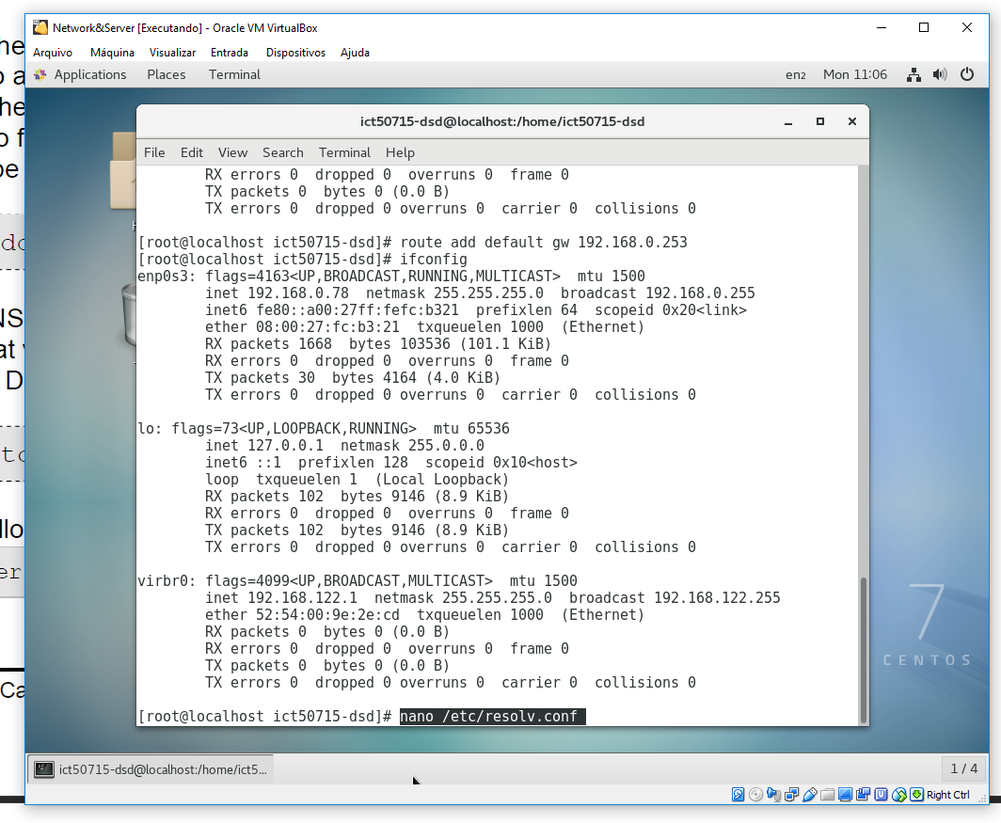

8 - Alter resolv.config

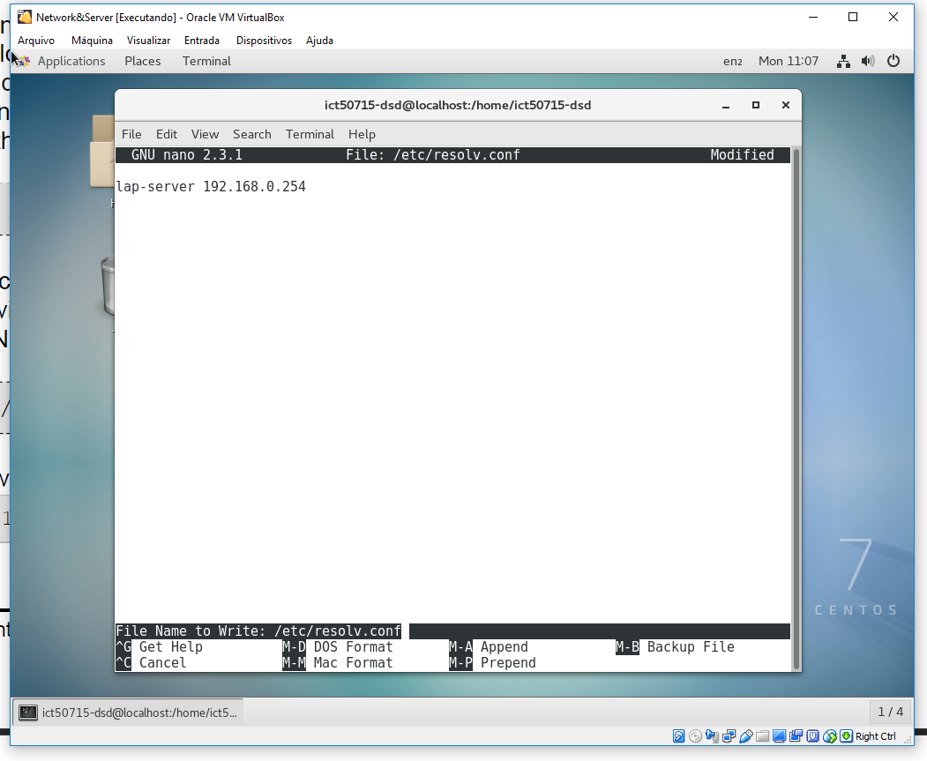

9 - Open and save resolv.config

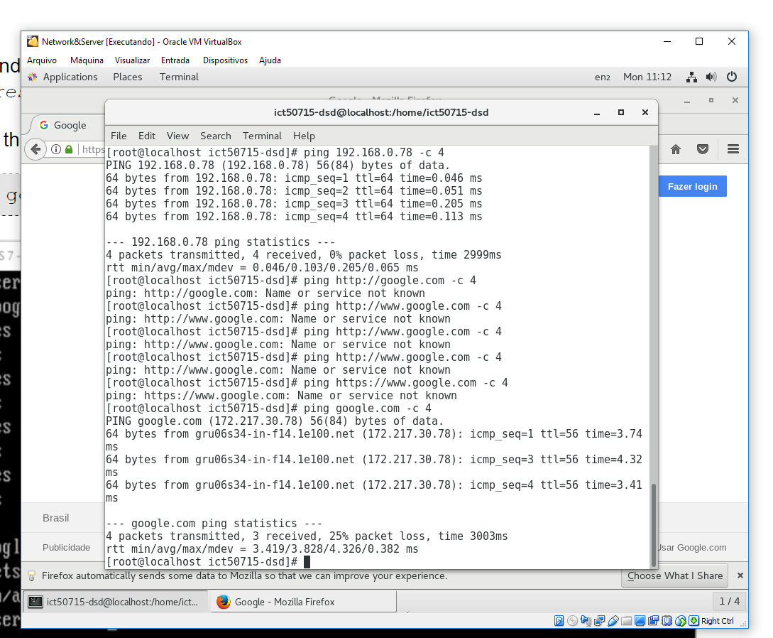

10 - Command to validate Google address

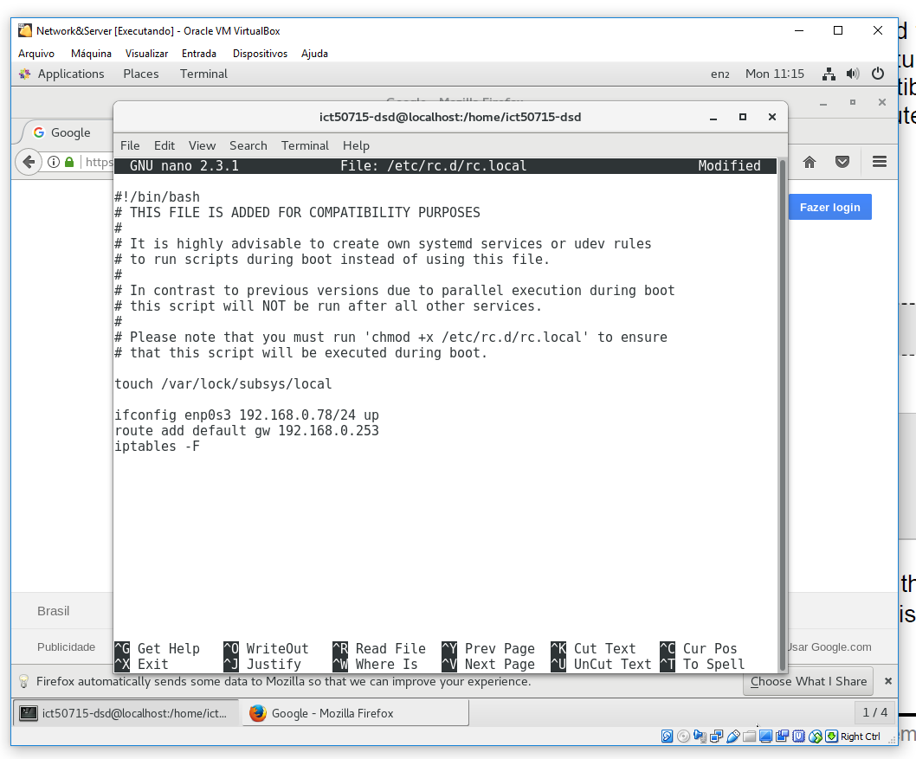

11 - Open and save rc.local to reboot

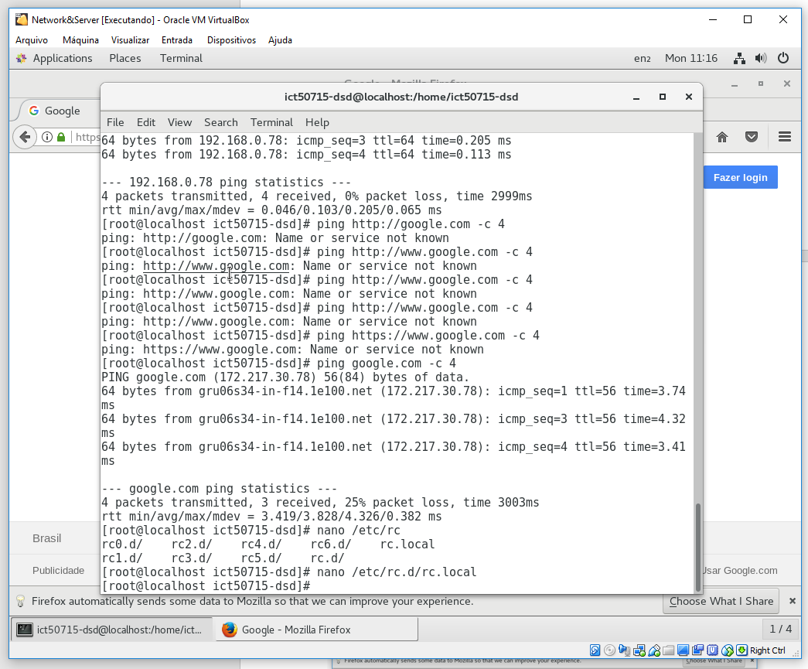

12 - Alter rc.local to reboot

* 1. **Install MariaDB and MySql DataBase**

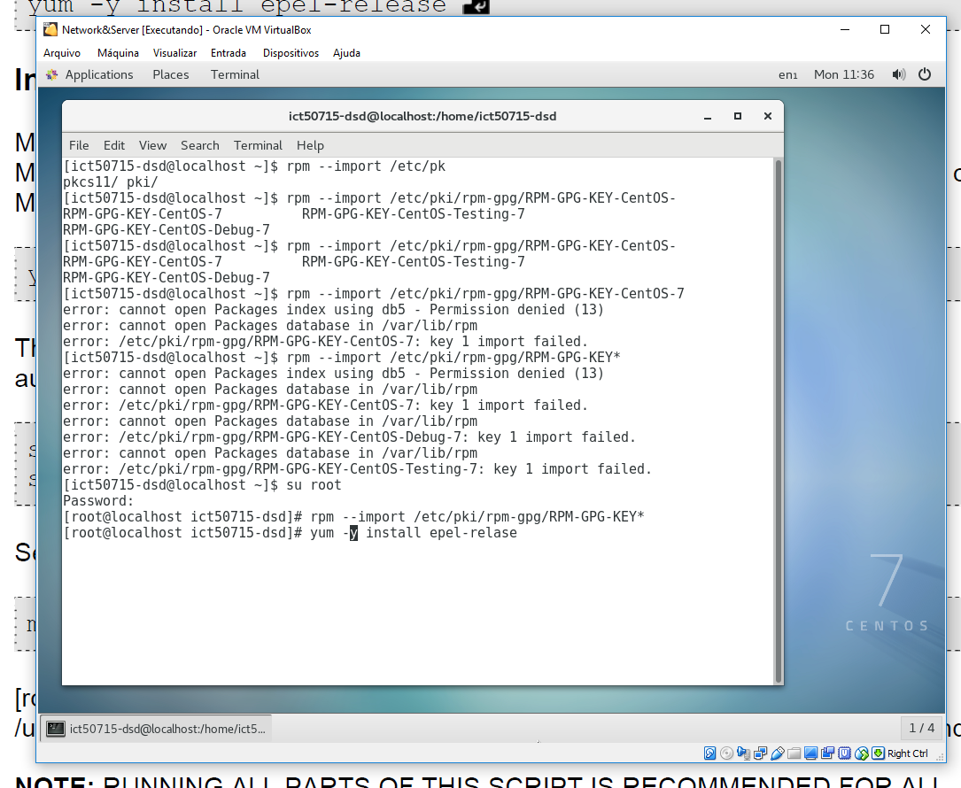

13 - Command to install packages necessary

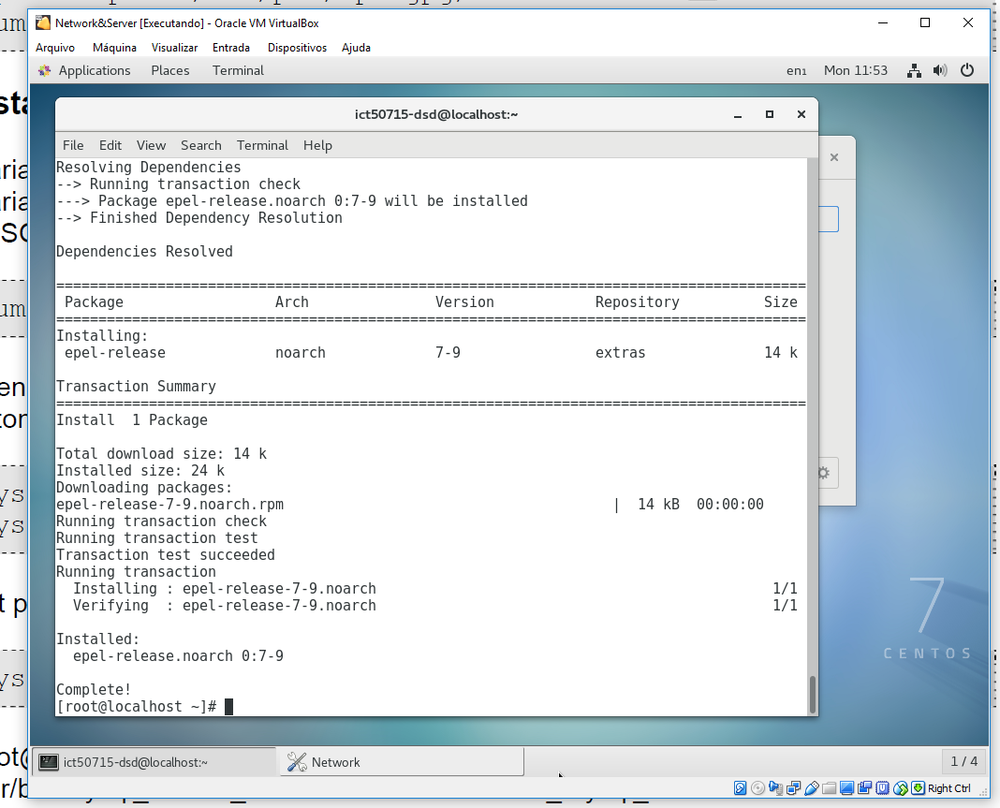

14 - Command to install packages necessary completed

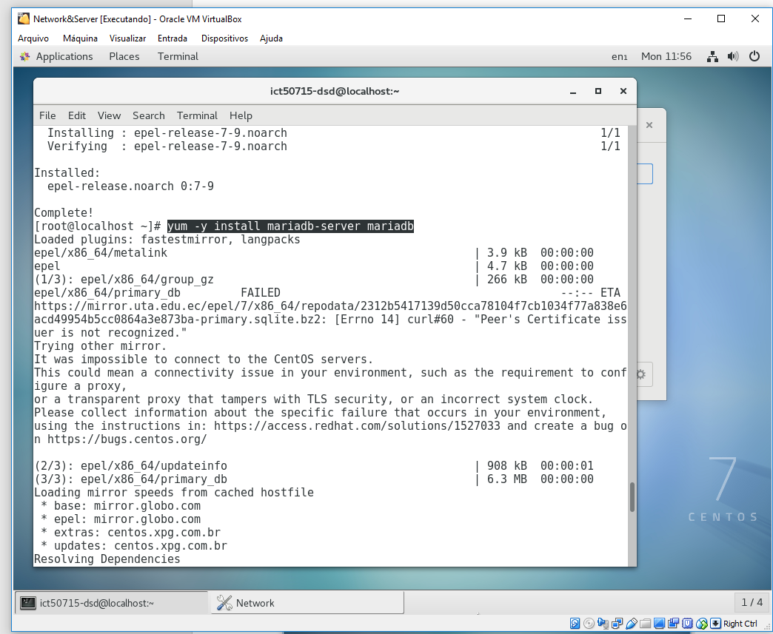

15 - Command to install MariaDB

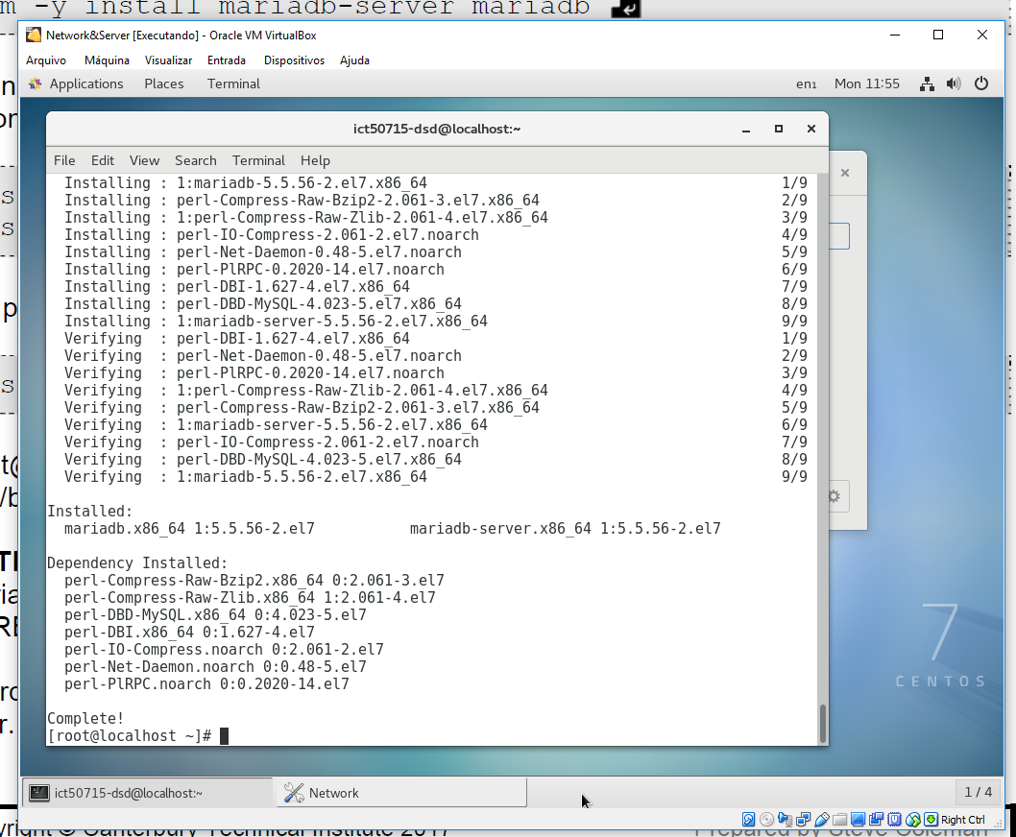

16 - Command to install MariaDB completed

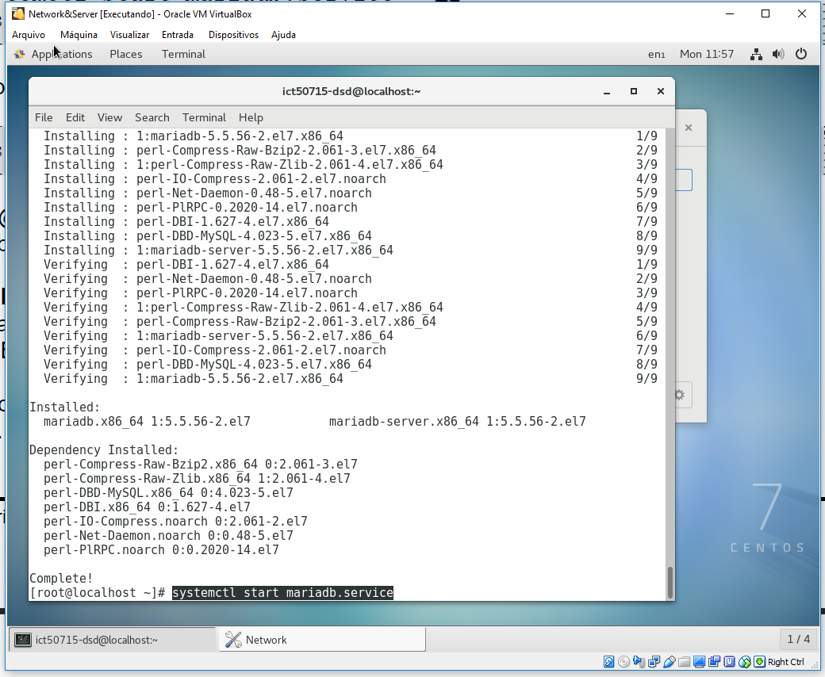

17 - Command to start MariaDB service

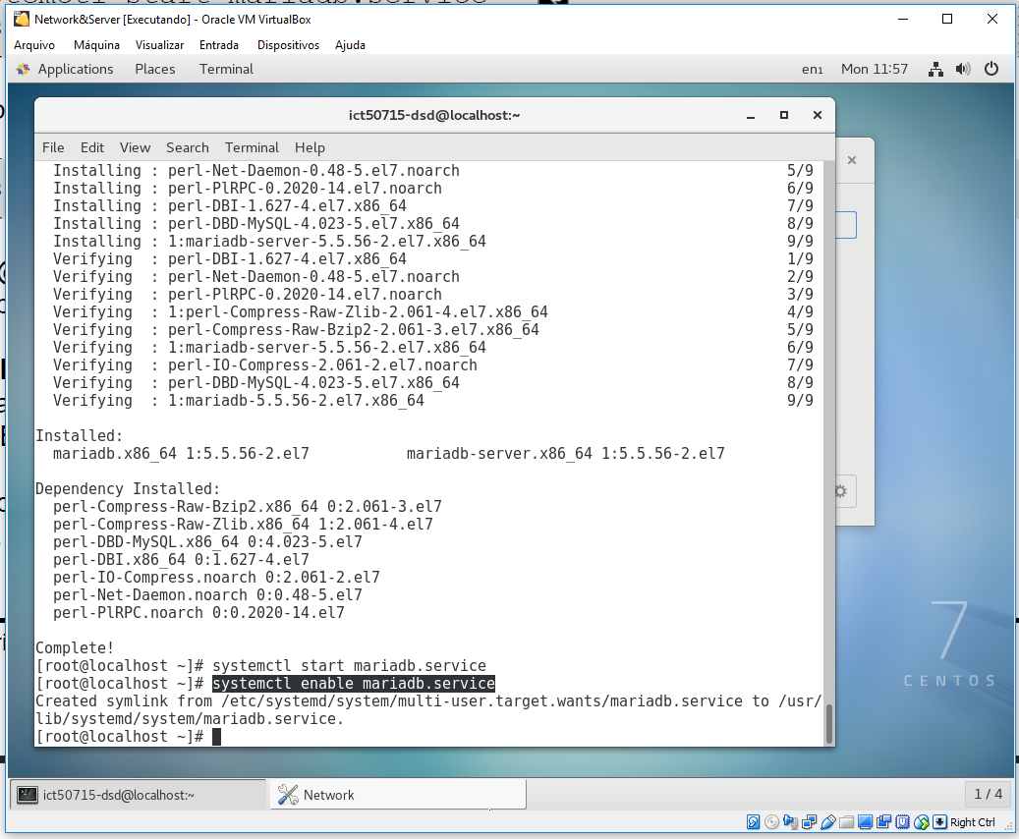

18 - Command to enable MariaDB service

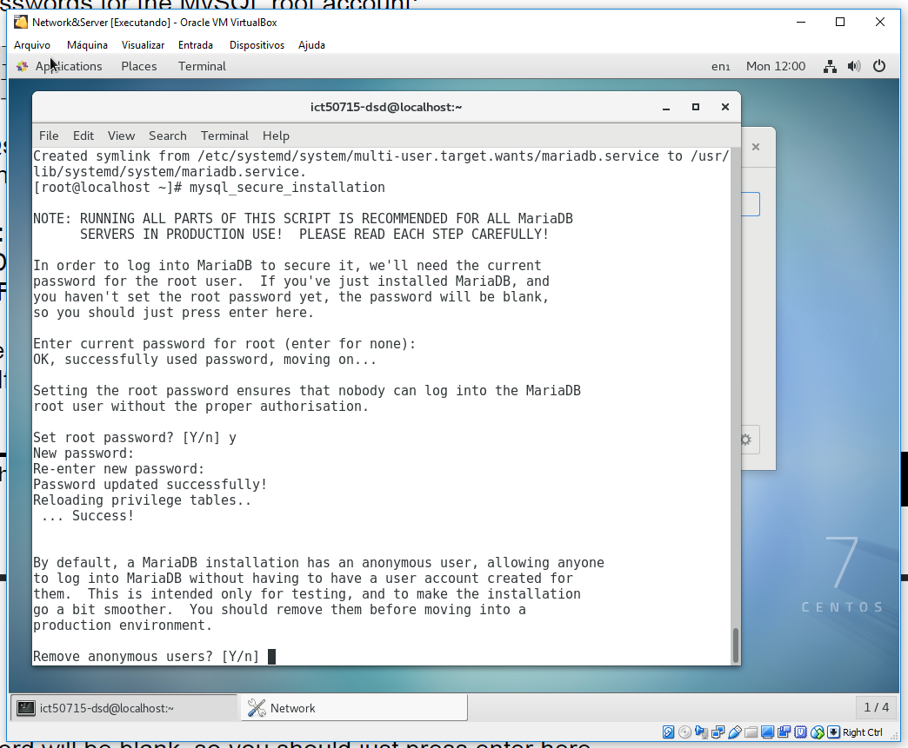

19 - Command to configure MySql from MariaDB

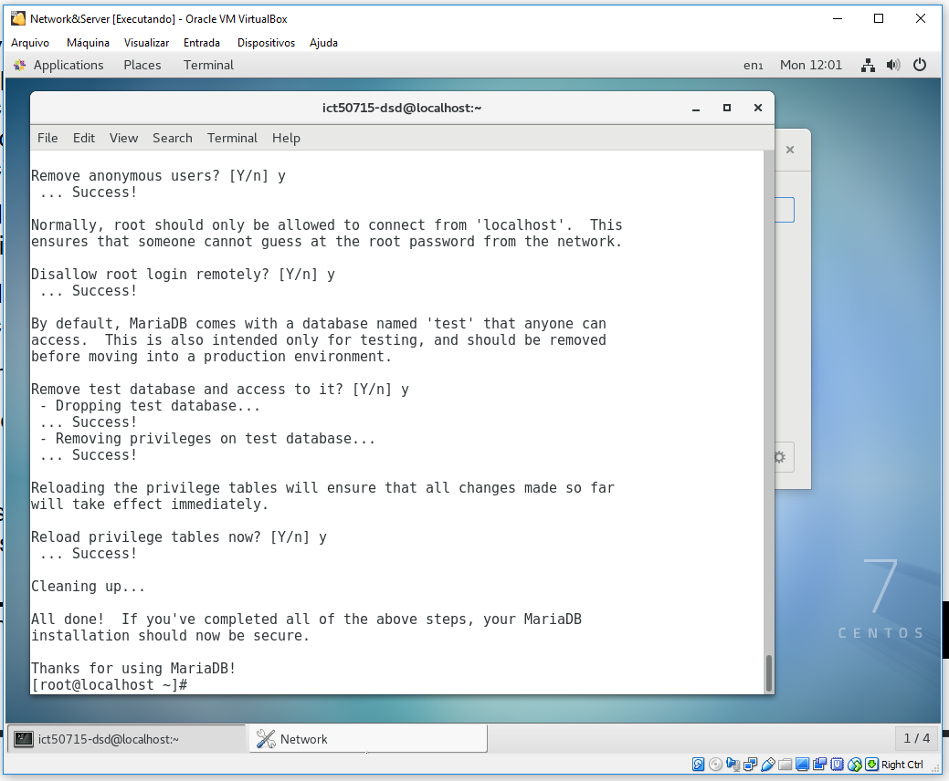

20 - Commands to configure new user

* 1. **Install Apache**

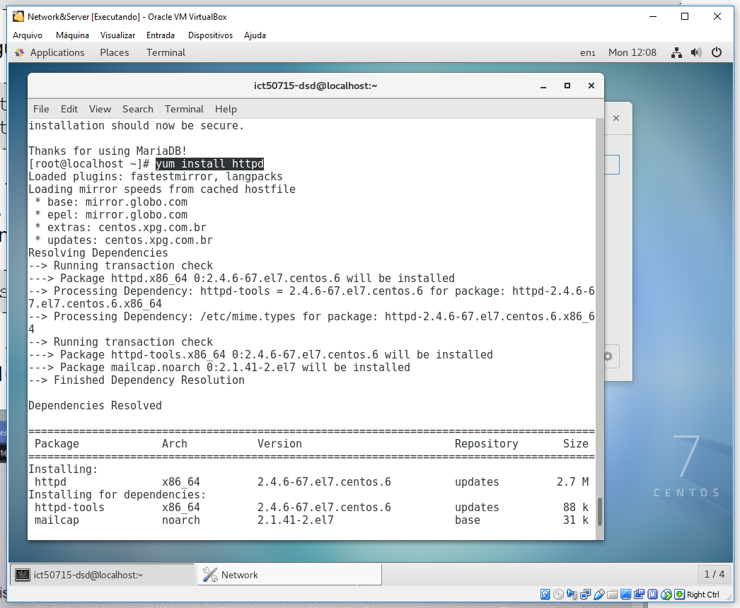

21 - Command to install apache server

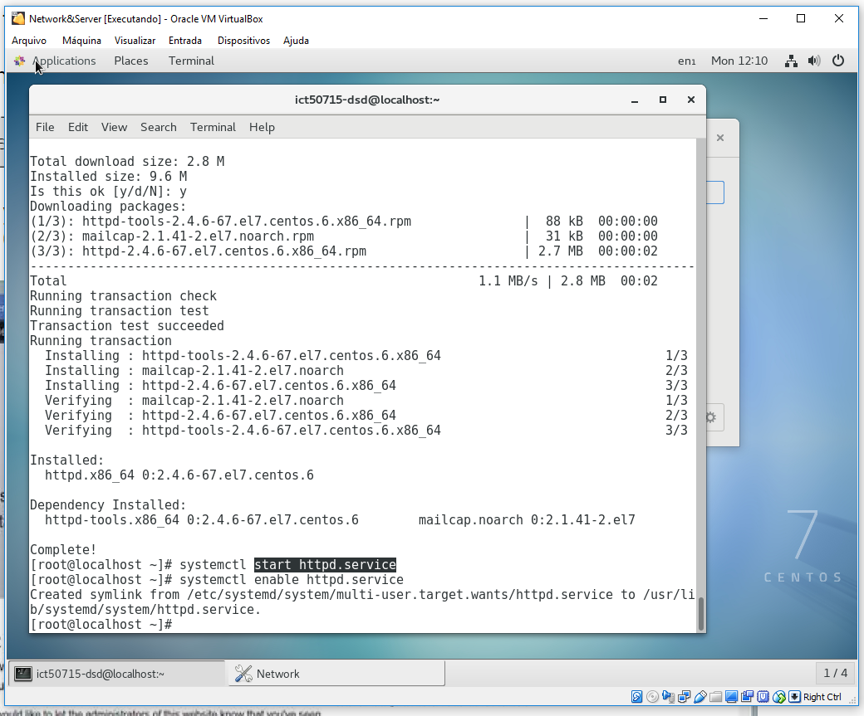

22 - Command to start and enable Apache service

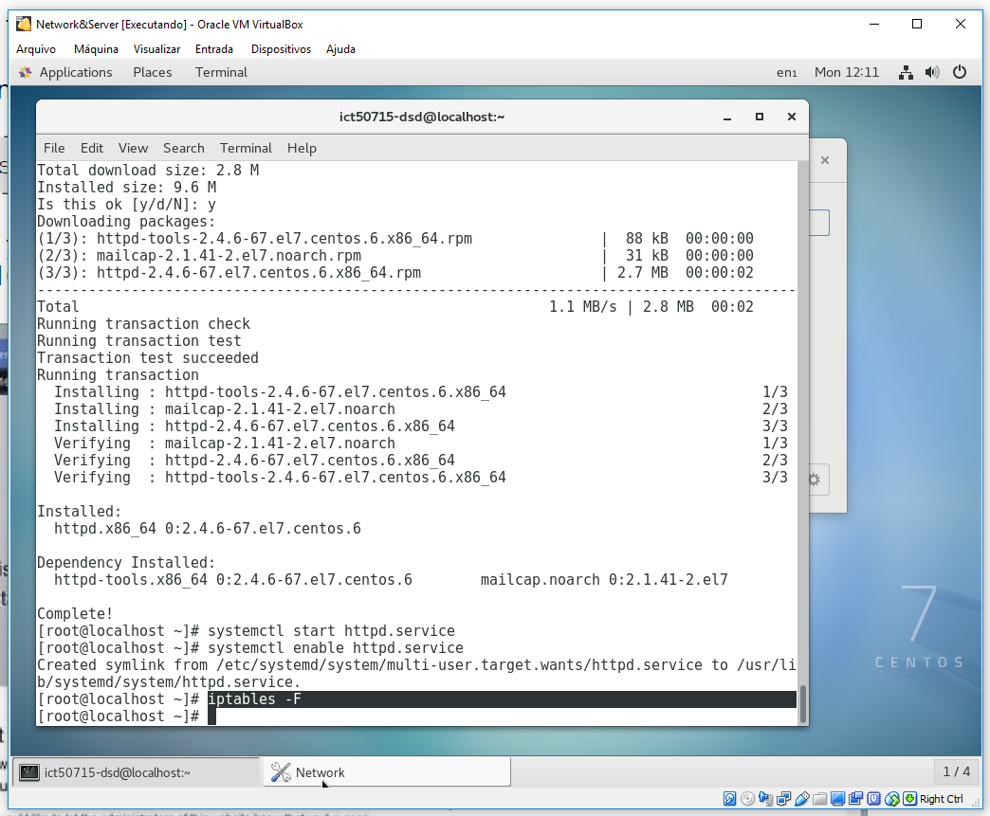

23 - Command to configure IPTABLES

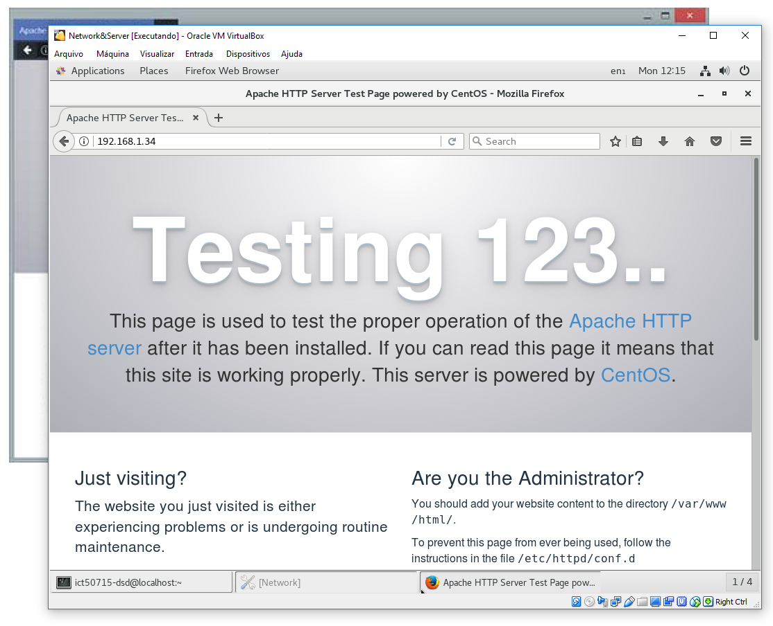

24 - Command to validate Apache instalation

* 1. **Install PHP**

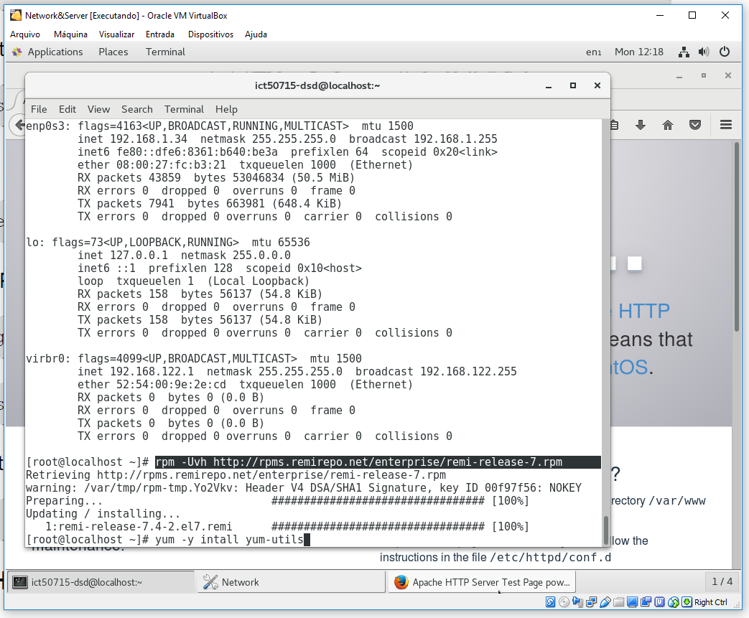

25 - Command to enable repository to PHP download

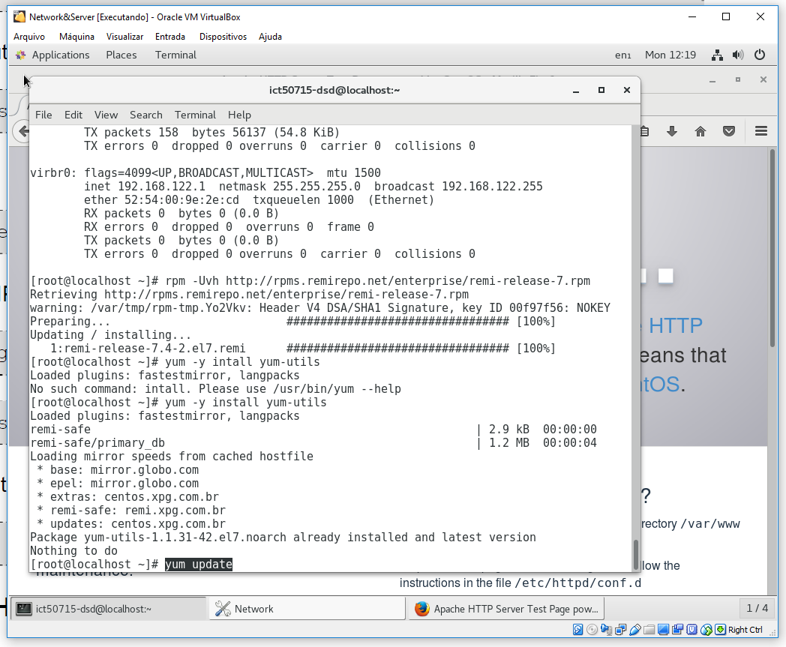

26 - Command to update repositories

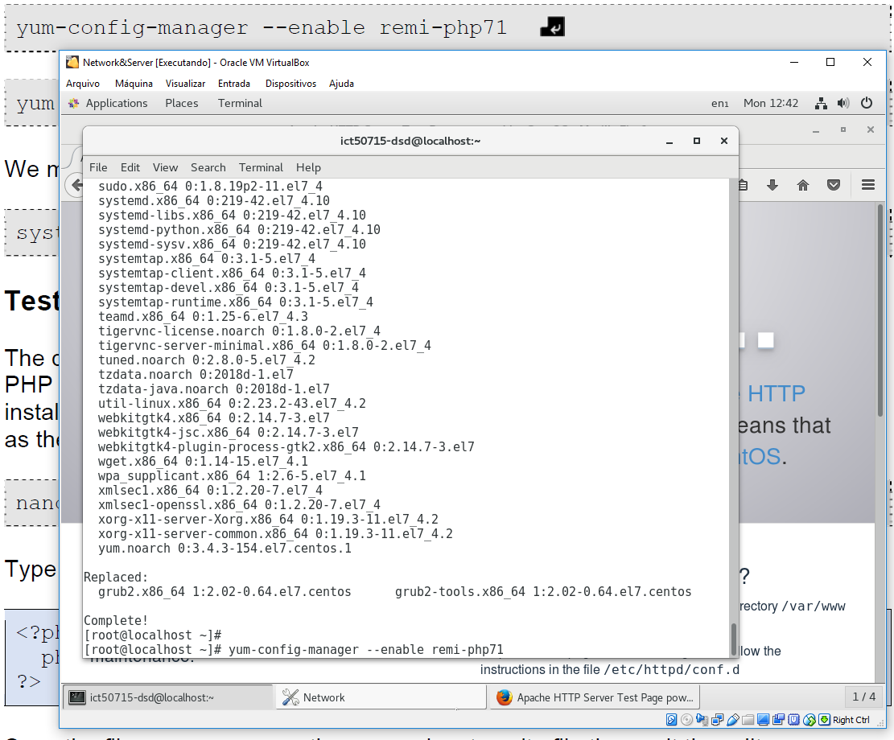

27 - Command to install PHP

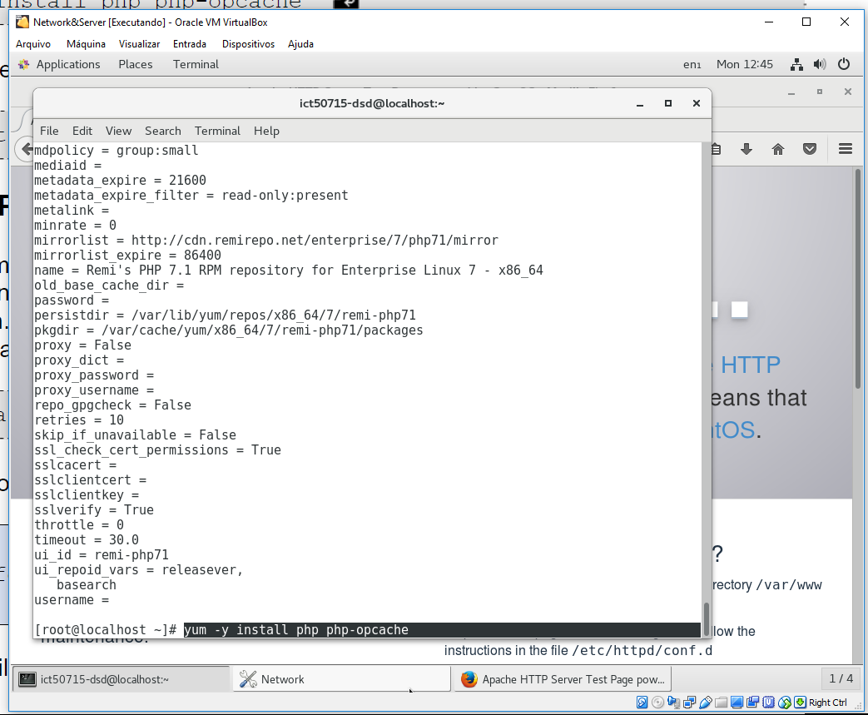

28 - Command to PHP - Apache

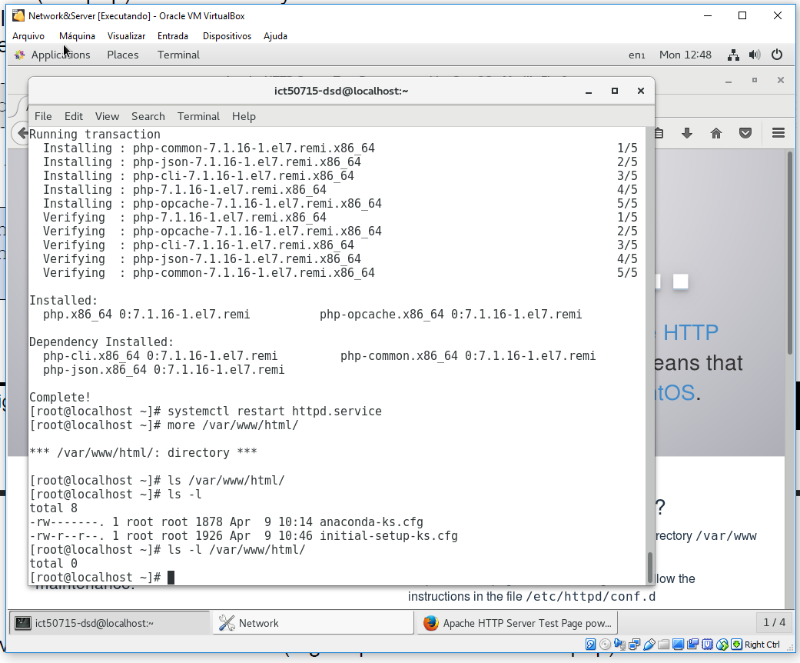

29 - Command to restart Apache service

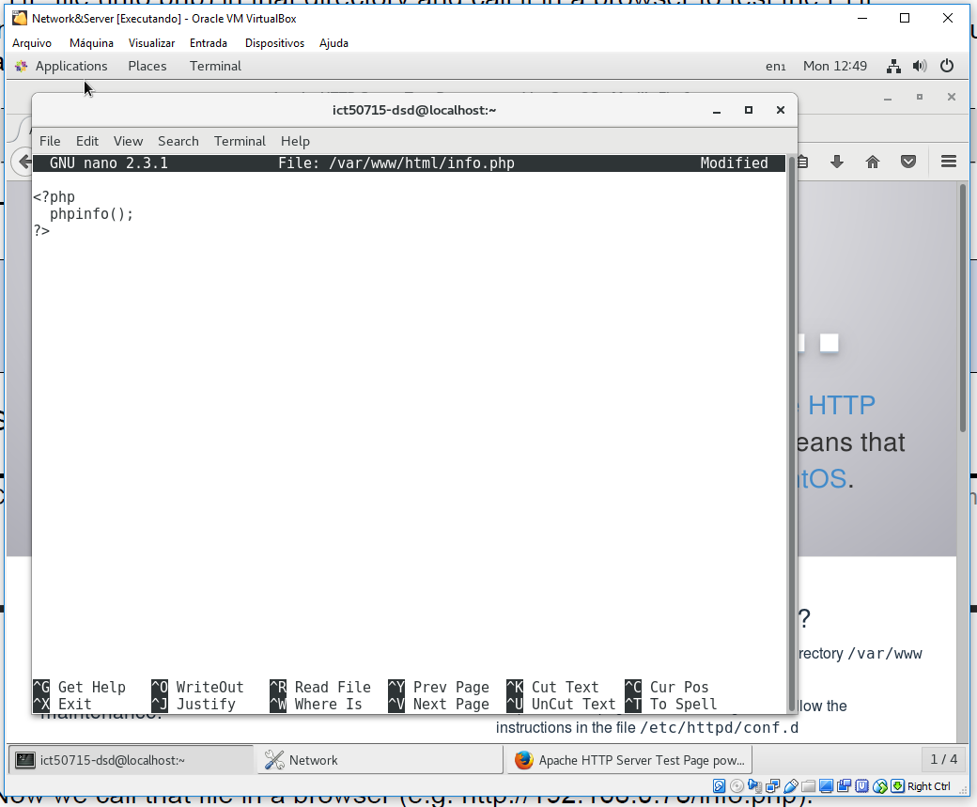

30 - Configure static page for PHP

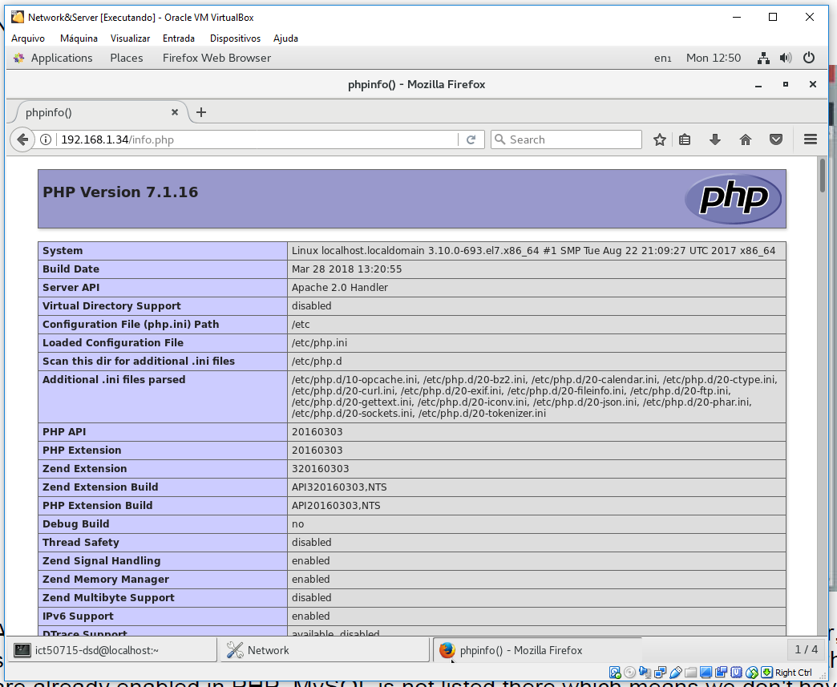

31 - View PHP describe

* 1. **Install PHP-MySql**

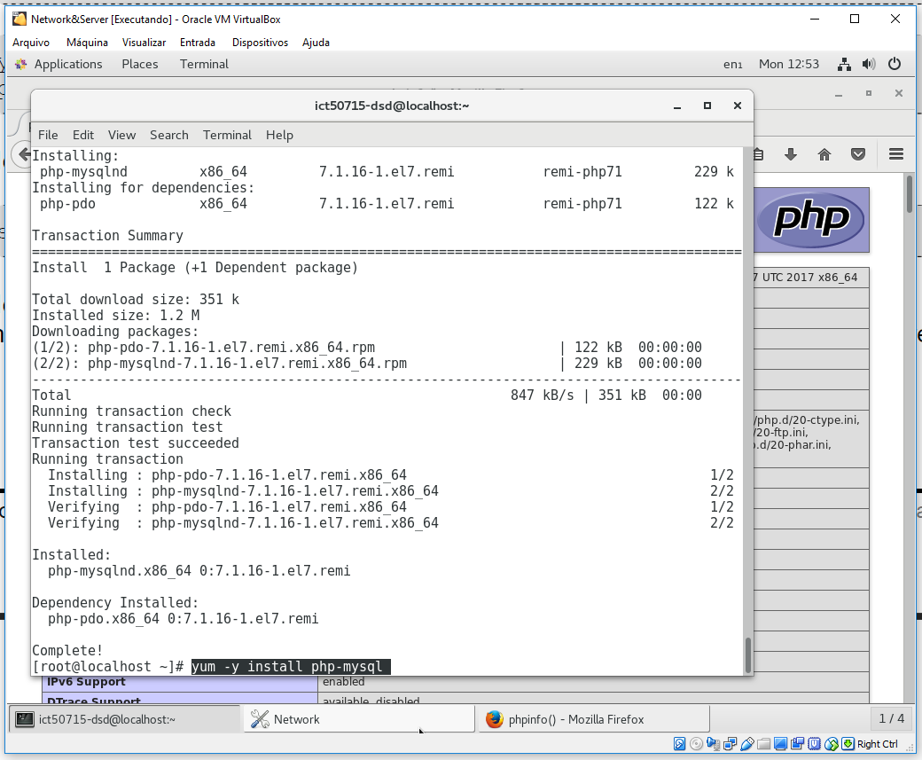

**32** - Command to install PHP-MySql

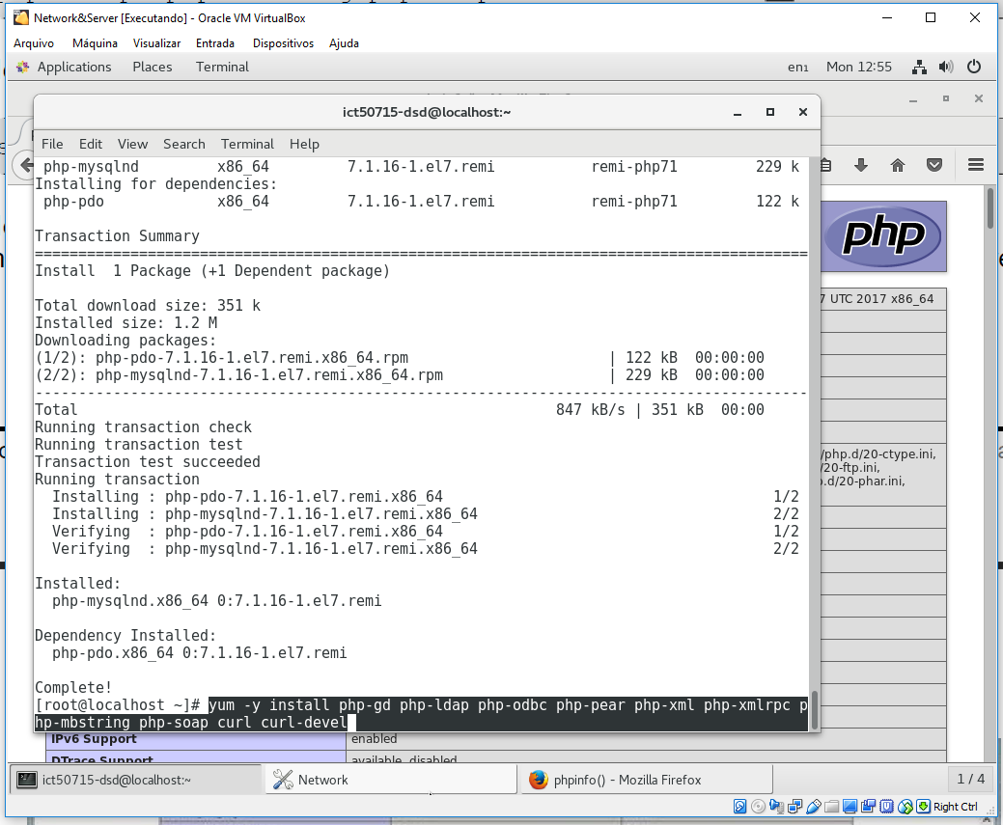

**33** - Command to install PHP-MySql completed

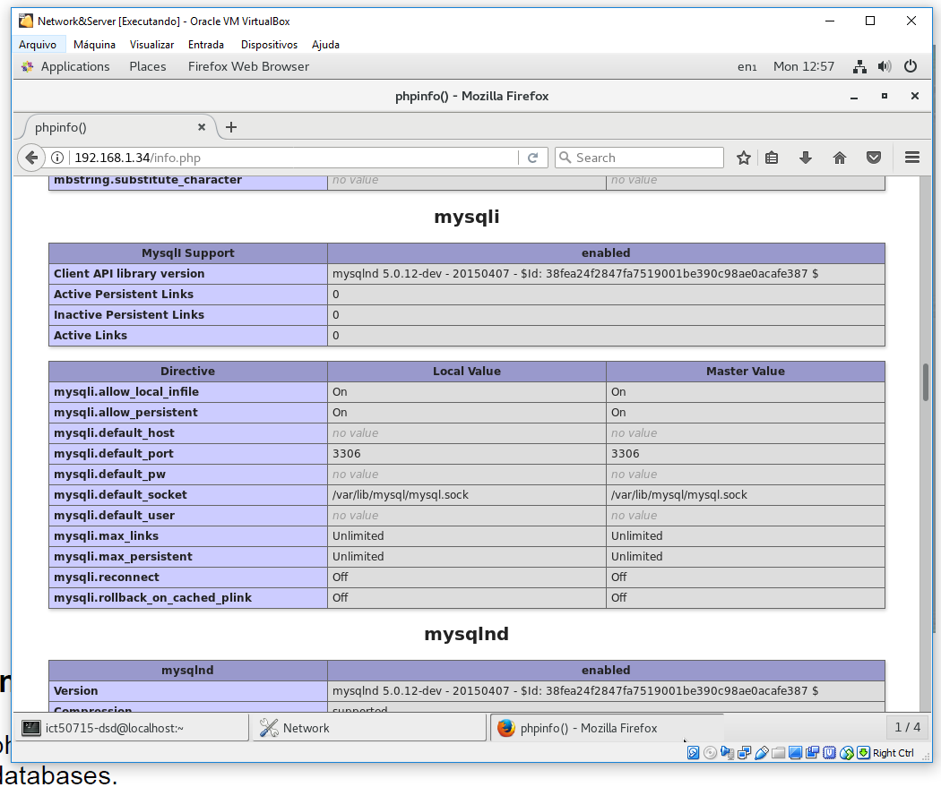

**34** - Describe PHP-MySql complet

* 1. **Install PhpMyAdmin**

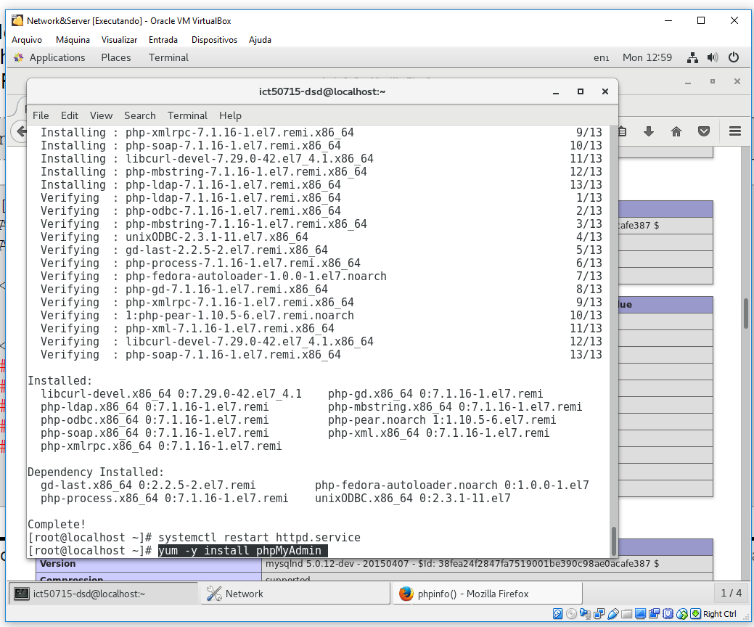

**35** - Command to install PHPMyAdmin

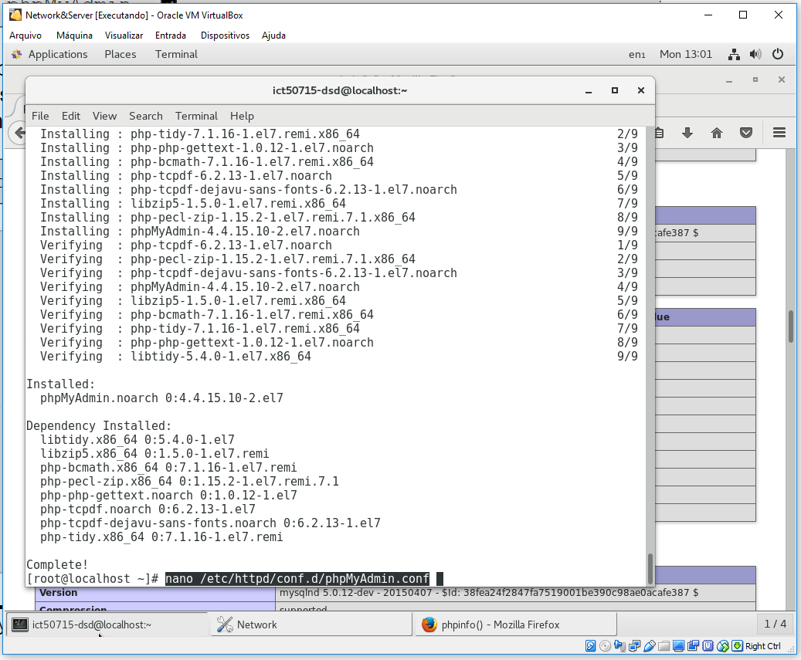

**36** - Command to Install PHPMyAdmin Completed

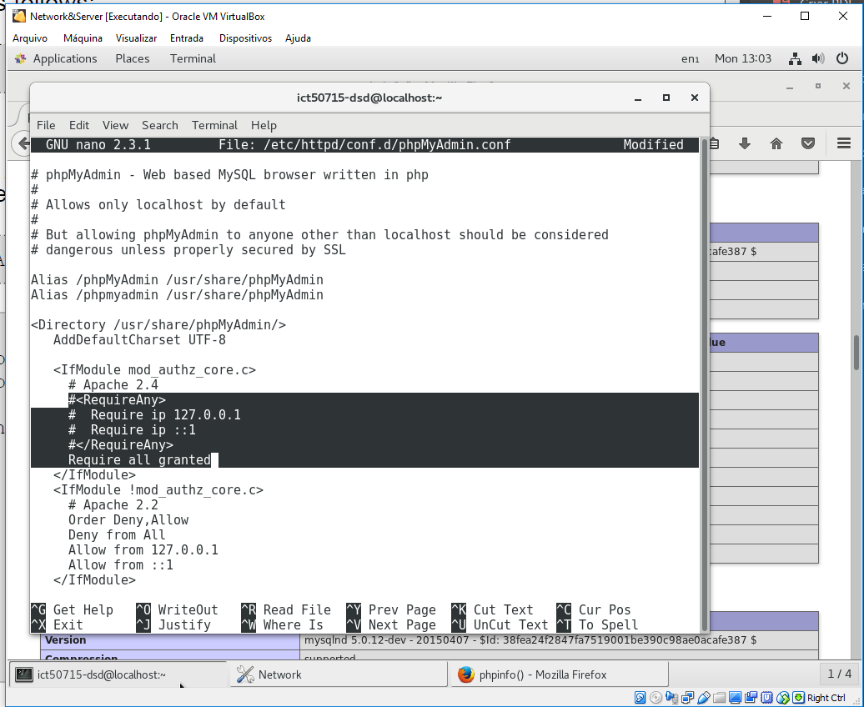

**37**- Configure apache enable external address

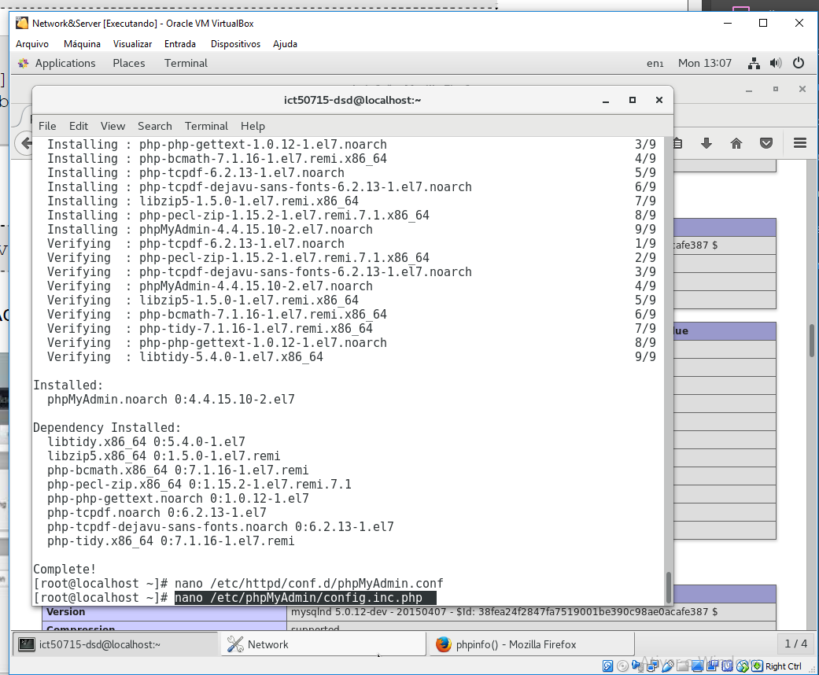

**38** - Alter config.inc.php

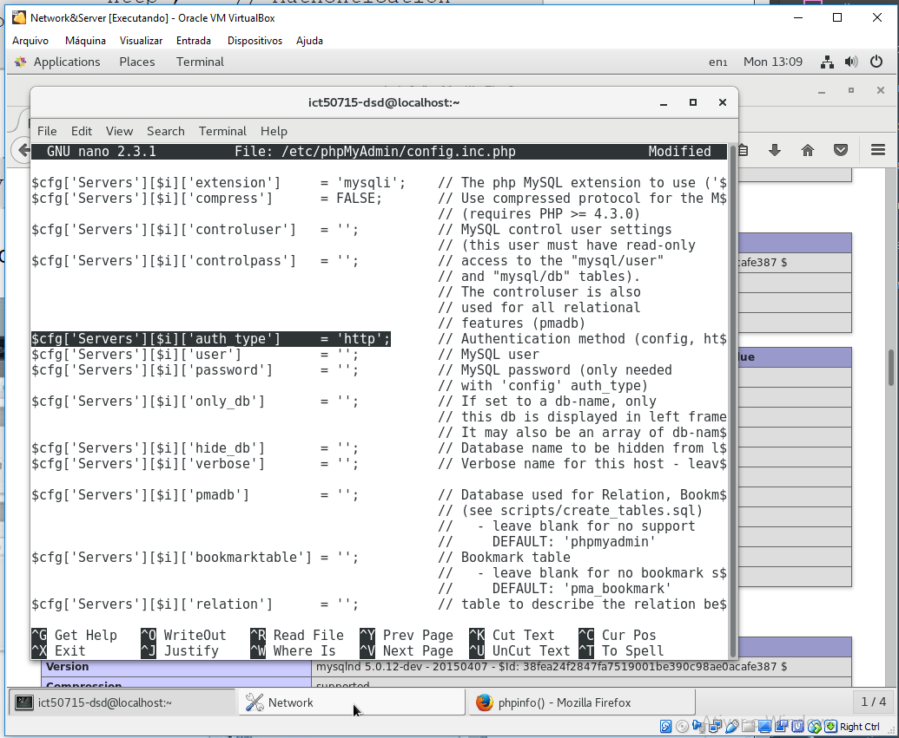

**39** - Alter config.inc.php to "http"

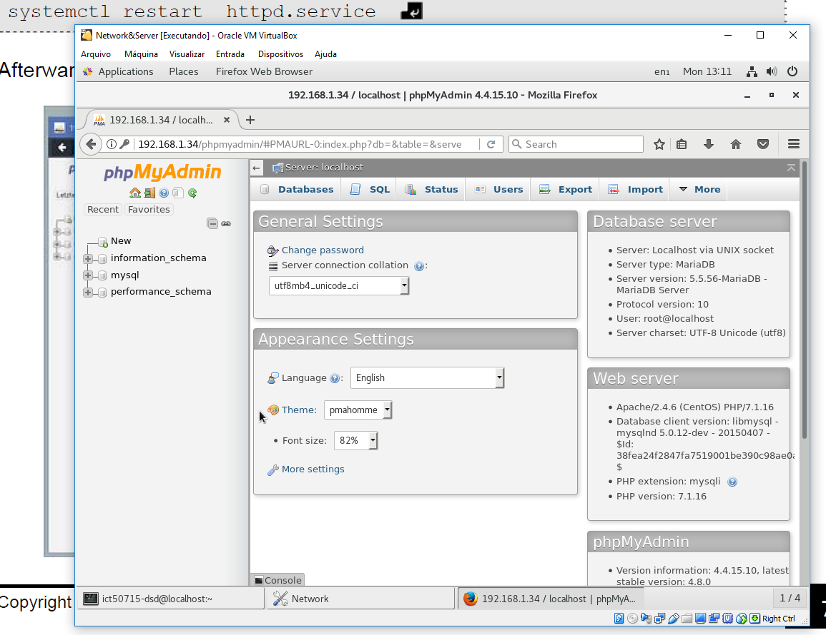

**40** - Validate PHPMyAdmin installed

* 1. **Configure LPA-stock-control users**
     1. **Administrator users:**

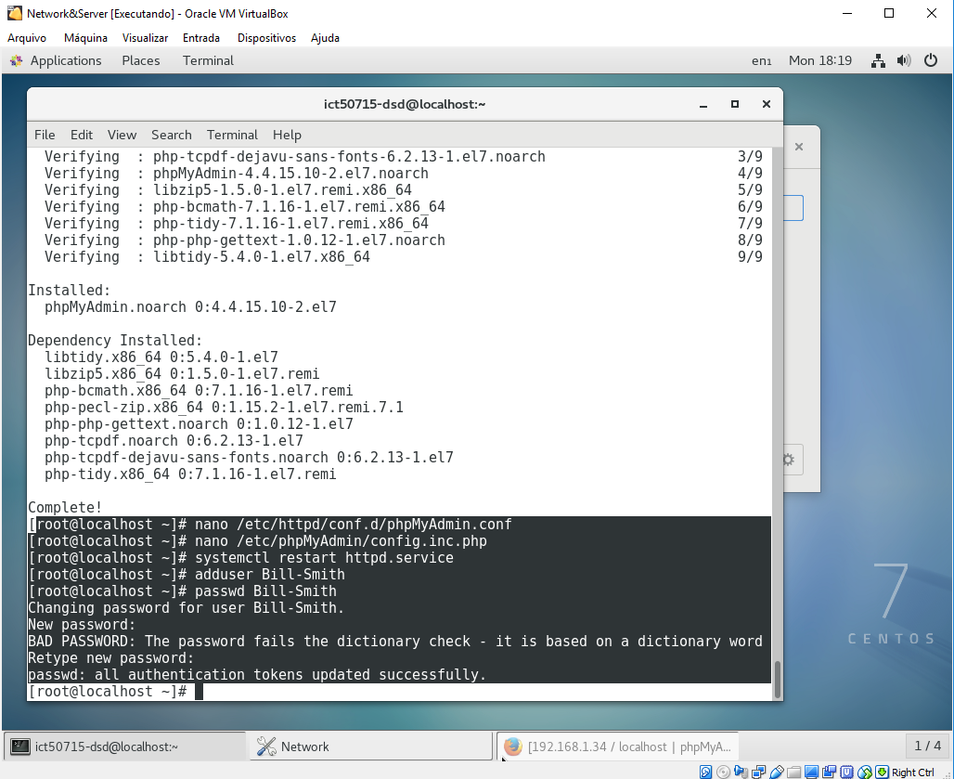

**41** - Create administrator User

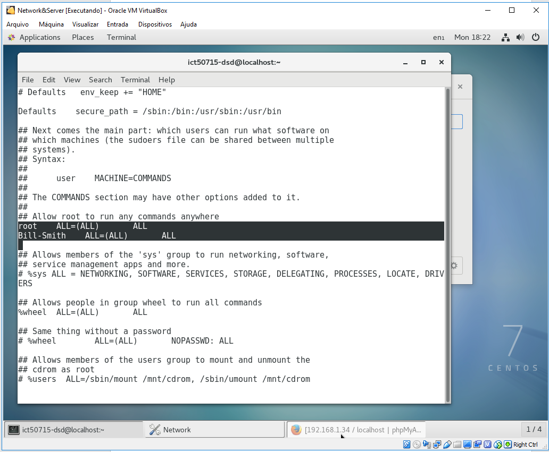

**42** - Move user to admin privileges

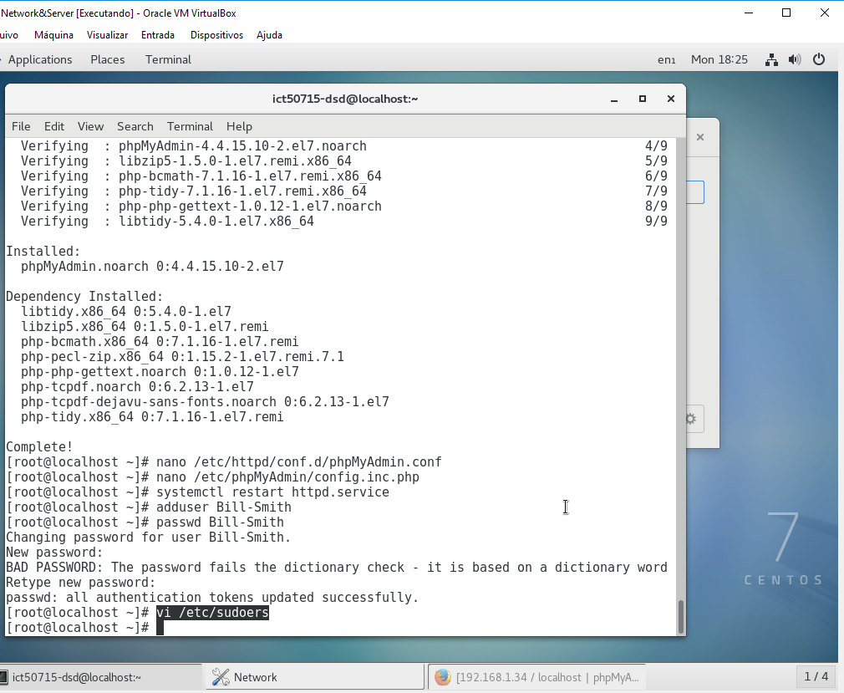

**43** - Alter sudoers

* + 1. **Others users:**

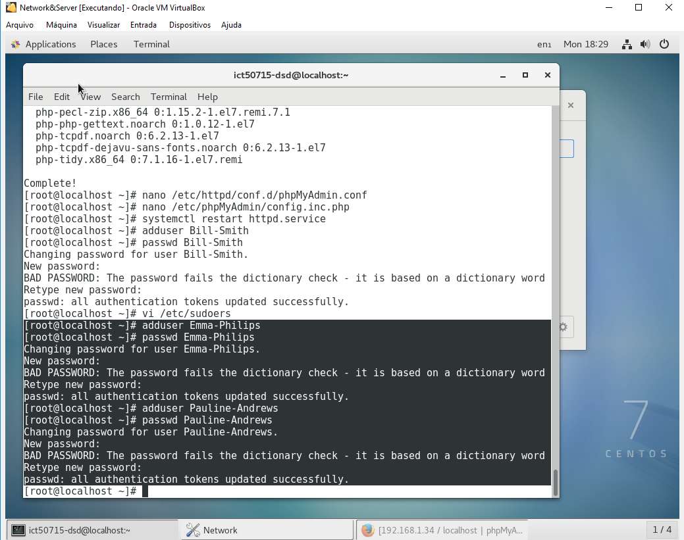

**44** - Create common users

1. **CONCLUSIONS**

Completed each part of this activity, transform my mind and evaluate the knoledges, because I can understand how use Linux S.O. and your services and how install a wer-server and a database in a enterprise environment.

1. **RECOMMENDATIONS**

Recommends this way using CentOS on clou dor on-promisse server to have a good environment executing and deploying applications in a enterpirse level with the minimal coast of resources.

1. **REFERENCES**

* [**https://www.centos.org/docs/5/html/yum/sn-yum-proxy-server.html**](https://www.centos.org/docs/5/html/yum/sn-yum-proxy-server.html)
* [**https://github.com/example42/puppet-yum/issues/99**](https://github.com/example42/puppet-yum/issues/99)
* [**https://www.unixmen.com/ifconfig-command-found-centos-7-minimal-installation-quick-tip-fix/**](https://www.unixmen.com/ifconfig-command-found-centos-7-minimal-installation-quick-tip-fix/)
* [**https://unix.stackexchange.com/questions/91970/yum-update-error-could-not-retrieve-mirrorlist**](https://unix.stackexchange.com/questions/91970/yum-update-error-could-not-retrieve-mirrorlist)
* [**https://www.youtube.com/watch?v=O1nF7HQAJGw**](https://www.youtube.com/watch?v=O1nF7HQAJGw)
* [**https://www.youtube.com/watch?v=xZqW6_6pE4M**](https://www.youtube.com/watch?v=xZqW6_6pE4M)
* **Material checkable**